COMPOUND LENSES
PHYSICS 102
Josiah Abel, Mari Martin, Dakota Johnson, Al Segovia and Erica Ruckman
April 6th, 2015
Instructor: Tamera Pavelec

OBJECTIVE: To determine the focal point of a single unknown lens in a Compound lens system.

BACKROUND: By combining more than one lens together a compound lens is constructed. This new system is used in many optical instruments. After the light rays pass through the first lens it will create an image for the second lens to use as its object to create an image of its own. The separation between the two lenses determines the relationship between the image created by the first lens (i₁) and the object for the second lens (p₂). (i₁= p₂)
$$\frac{1}{f_{1}}=\frac{1}{p_{1}}+\frac{1}{i_{1}}$$
And
$$\frac{1}{f_{2}}=\frac{1}{p_{2}}+\frac{1}{i_{2}}$$
MATERIALS:
- A Flat-Convex Lens (A)
- A Concave-Convex lens (B)
- A Convex-Convex lens (,C)
- A Concave-Concave lens (Z)
- Four lens holders
- A high intensity light source
- A long flat metal plate with built in meter stick, an optical rail (to mount the assemblies on)
- A sheet of white printer paper (Backdrop for image)
- ruler

PROCEDURE: Four lenses were chosen with three of the lenses having known focal lengths. The three lenses with known focal lengths were labeled Lens A, Lens B, and Lens C and the lens with the unknown focal length was labeled Lens Z. The lenses were then placed into lens holders. A metal rail was placed onto a table. The light source was placed into the groove at one end of the rail so that it would not move. Lens holders A and B were placed on the rail with lens holder B in between Lens holder A and the light source. A white notebook was placed on the rail in front of the lens holder which was used as a screen to focus the images. The lights in the room were turned off and the light source was turned on. The lens holder and notebook were then moved until a clear image was cast on the notebook. The distances between the lens holders and the light source, the distance between the lens holders and the notebook, and the distance between the two lens holders were then measured. If the image could not be focused on the notebook a small piece of paper was moved in between the lenses and the light source in order to find a virtual image. Once the virtual image was found the diameter was measured and it was noted whether it was inverted or not. Lens B was then replaced with lens Z and the same steps were used. Lens A was then replaced with lens B and then Lens C with the same steps being performed for each lens.

DATA:
Compound Lenses
Position--> | Object (cm) | Object Size  (diameter -cm) | Lens  Closest to light  (cm) |  | Lens  farthest from light  (cm) |  | Image (cm) | Image Size  (diameter -cm) | Image
BA | 5 | 4 | B | 41 | A | 45 | 96 | 5.2 | upside down
ZA | 5 | 4 | Z | 34.3 | A | 38 | 25 | 1.5 | upside down
ZB | 5 | 4 | Z | 31.2 | B | 35 | 21 | 1.8 | upside down
ZC | 5 | 4 | Z | 31.8 | C | 36 | 22 | 1.8 | upside down

The focal point for Lens A was 27.86 cm
The focal point for Lens B was 24.90 cm
The focal point for Lens C was 14.26 cm
 | Calculated Focal Lengths
BA | 21.10 | cm
ZA | 23.95 | cm
ZB | -108.60 | cm
ZC | 12.89 | cm

In the following images the Blue sections represent the lens used in that trial of the experiment. Red represents where the focused image of the object was located with respect to the light source. The yellow represents the light source shining from left to right through the blue lens.
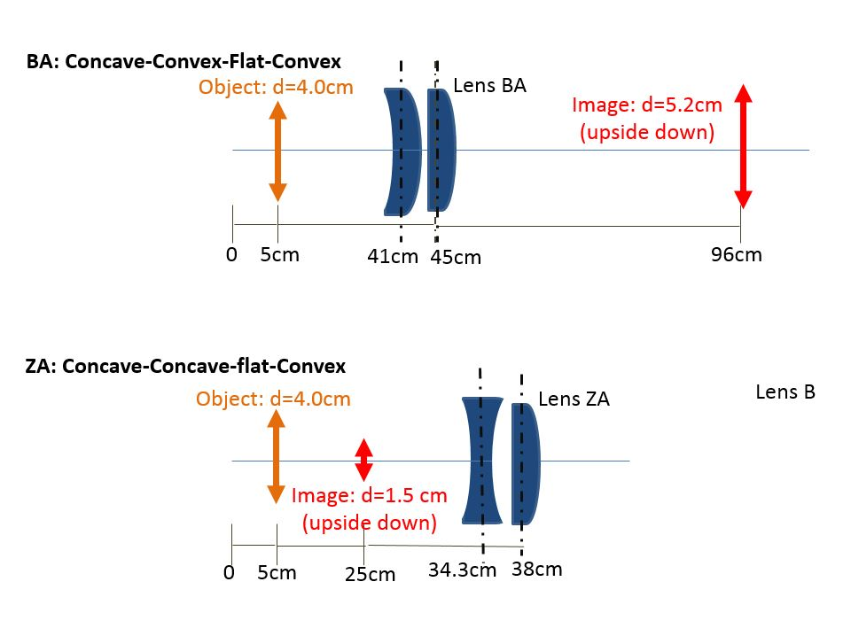
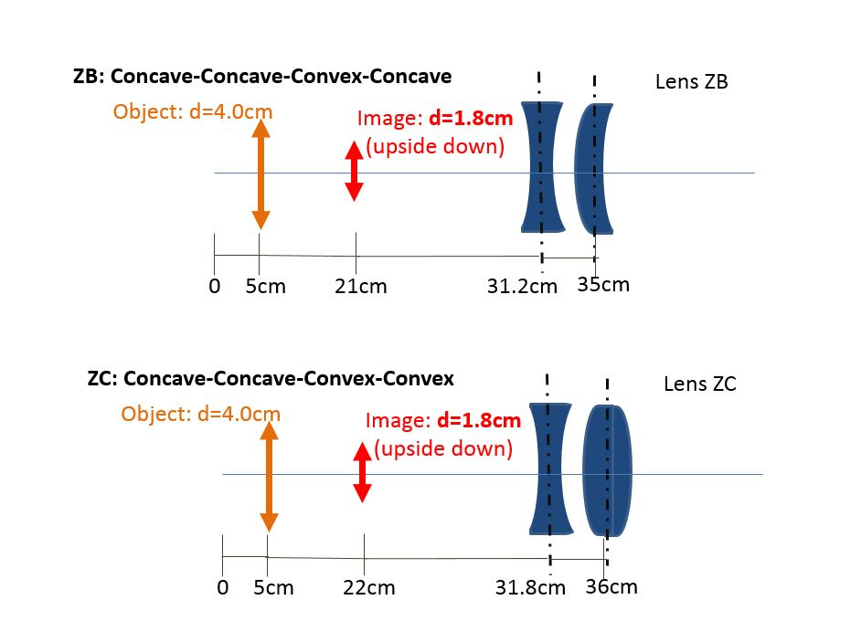
RESULTS:
The Calculated Focal Point for lens combination BA = 21.10 cm
The Calculated Focal Point for lens combination ZA = 23.95 cm
The Calculated Focal Point for lens combination ZB = 108.6 cm from the front of lens Z
The Calculated Focal Point for lens combination ZC = 12.89 cm
The Calculated Focal Point for lens Z = 31.12 cm
CONCLUSION: Using the same concepts used for a single lens, It became possible to calculate a single focal point in a compound series of lenses.

